# Macintosh HD:Users:z018620:Dev:Helps:Icons:RapiTag:RapiTagAppIcon-01.pngRapiTag – User Guide

Version 1.2

3/13/2019

## Introduction

RapiTag is a standalone application for encoding RFID EPC test tags using the encodings used in Target’s supply chain. It works with proprietarily encoded EPC GIDs that contain Target’s DPCI number, as well as national brand merchandize that uses an EPC encoded, serialized GTIN, or SGTIN. The app scans the target RFID EPC tag, and can scan printed bar codes on both blank RFID tags or UPC product labels or accept direct user input. Once all data has been collected, DPCI + Serial Number or GTIN + Serial Number, the encode button is enabled and you can encode the tag. Upon success, a green check is displayed and the serial number is incremented by one. If not, a red circle with a line through it is displayed.

**Update**: RapiTag has been updated to encode proprietary TCIN and TIAI tags, used internally to tag Target retail and non-retail items.

## Requirements

An iOS device (iPod, iPhone, iPad) running iOS 9.x or higher (for Data Matrix barcodes)

A supported Zebra RFD8500 RFID reader

The RapiTag app – one of:

* <https://github.com//timmilne/RapiTag>
* <https://git.target.com/TimMilne/RapiTag>

## Setup

Before launching RapiTag, you must connect the Zebra reader using iOS Settings to connect via Bluetooth. Click on the settings button and configure Bluetooth as outlined in the next section.

## Bluetooth Setup

### On the RFID reader

Turn on the Bluetooth reader

Press and hold the Bluetooth paring setup button until the blue light is flashing slowly (if you just turned it on, or installed a new battery, it may already be flashing)

### On the iOS device

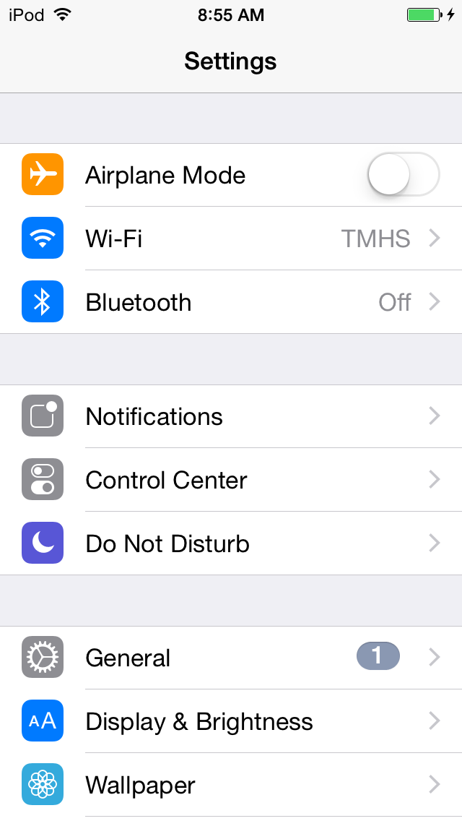

Open Settings and click on Bluetooth:

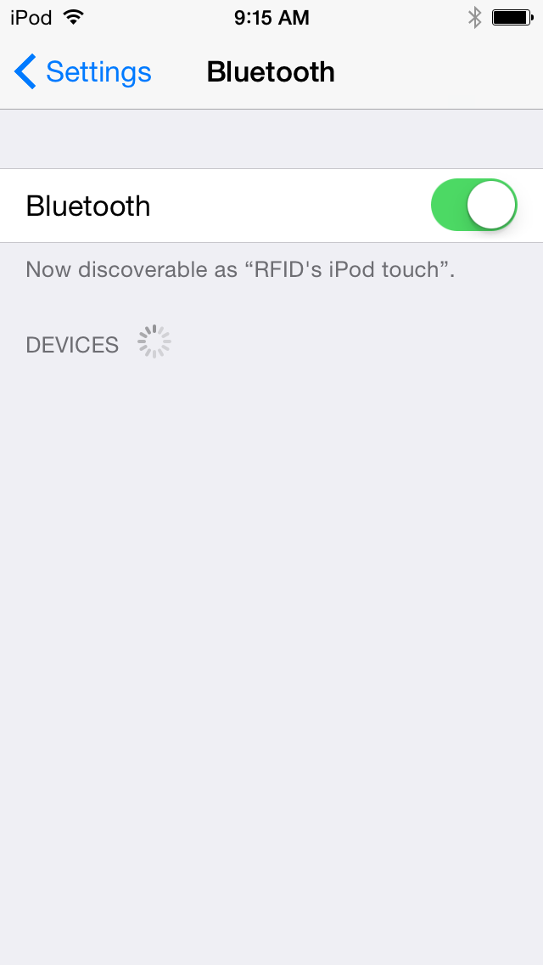Make sure Bluetooth is on:

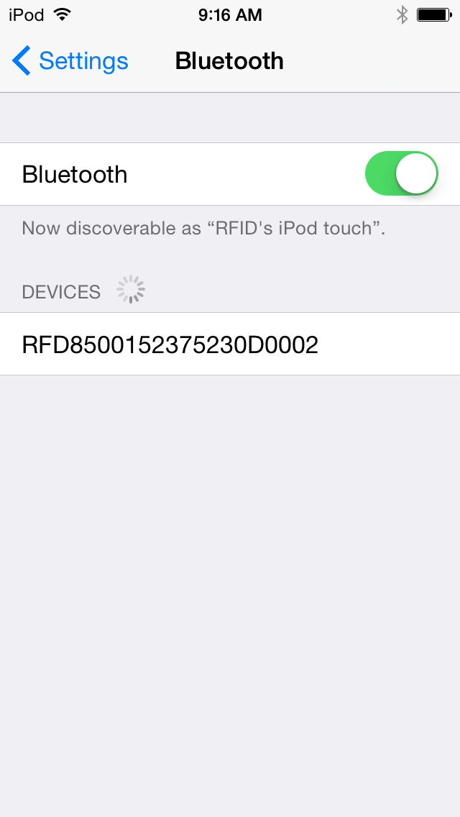With the blue Bluetooth pairing light flashing on the RFID handheld, select the RFID device in the devices list:

### On the RFID reader

The Bluetooth pairing light will now begin flashing more quickly. Pull the trigger on the handheld to confirm pairing (this is a security feature – you must have physical possession of both devices to successfully pair them).

### Macintosh HD:Users:z018620:Pictures:iPhoto Library.photolibrary:Masters:2015:09:21:20150921-091654:IMG_0014.PNGOn the iOS device

The RFID device should now show as connected. If not, repeat the steps in this section until a successful connection is established:

You should now be paired, and can open the application.

## Launch RapiTag

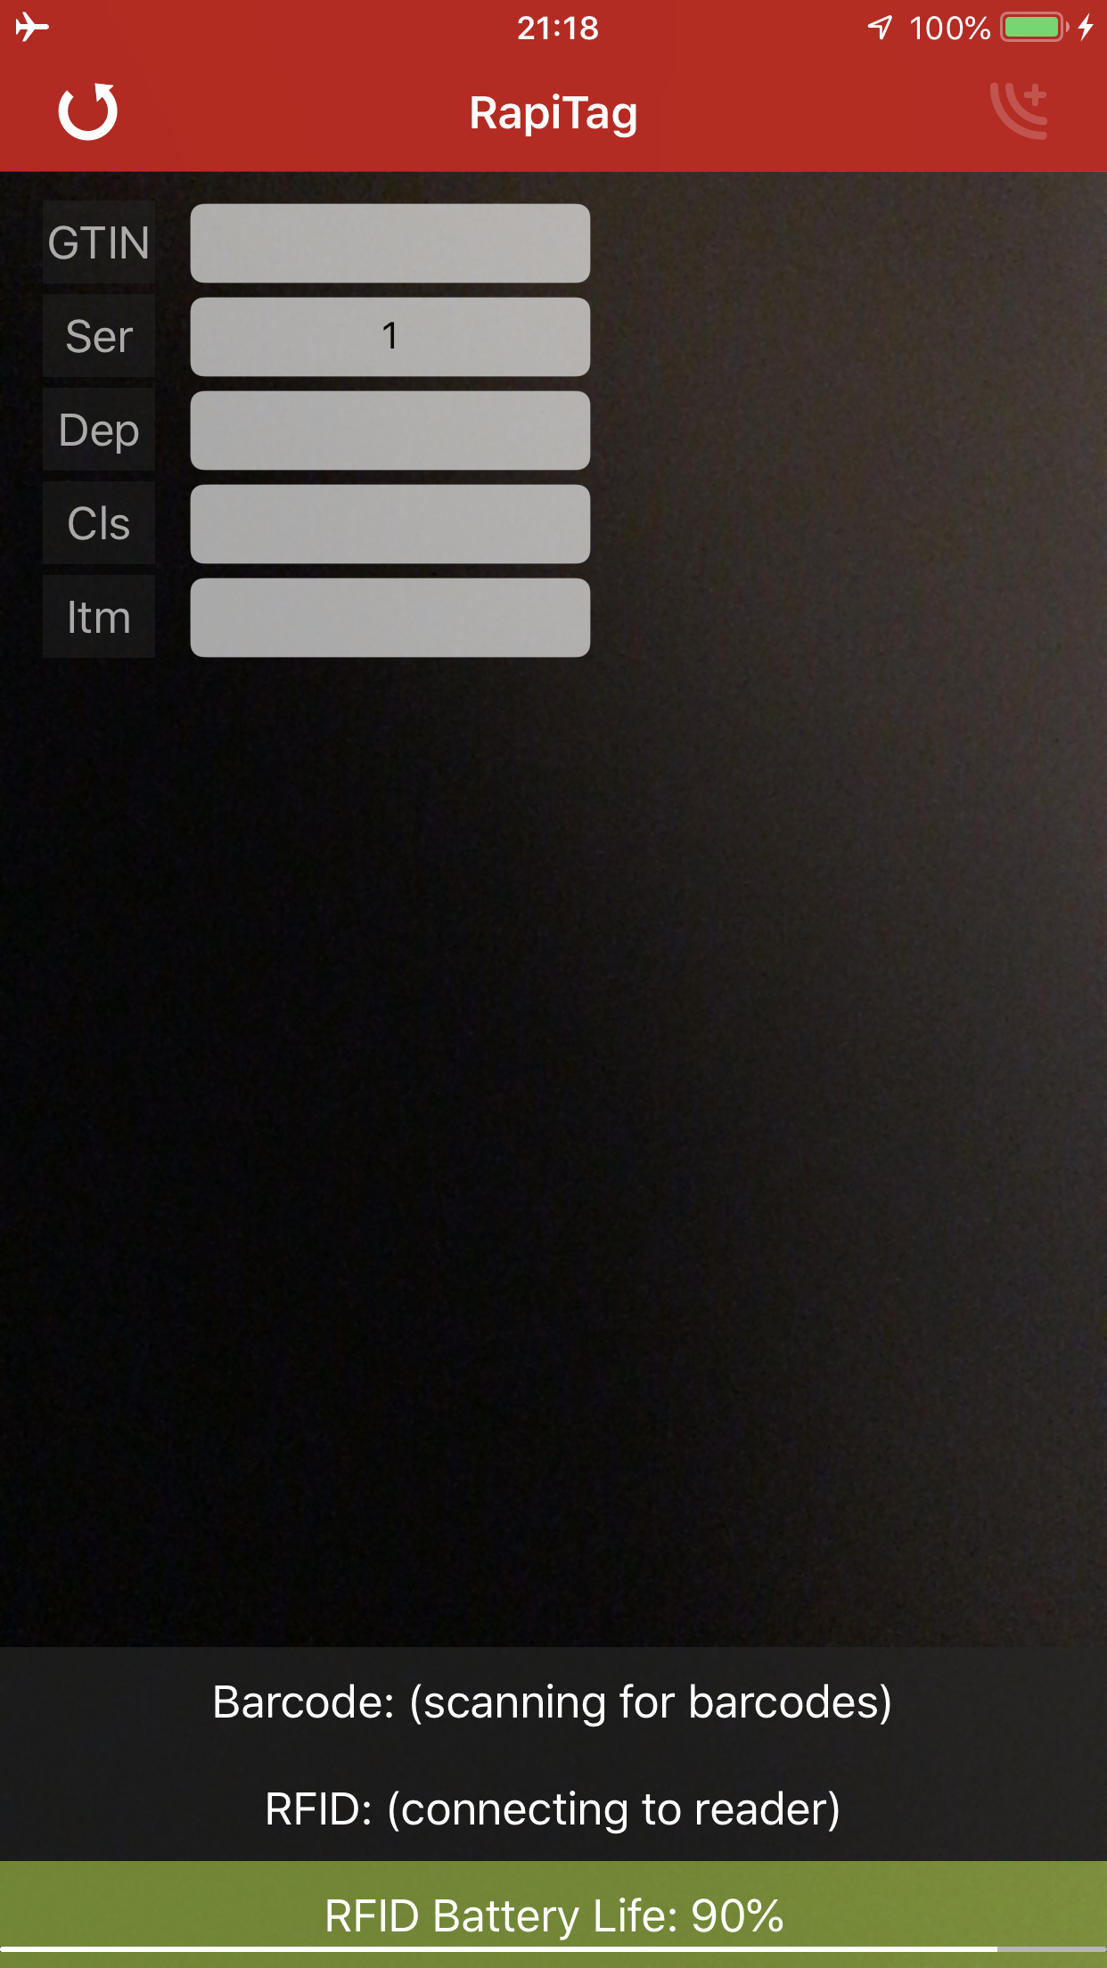If the reader is properly connected, you should see the RFID Battery Life displayed (see troubleshooting if not), and the RFID label should say “Scanning for tags” (see troubleshooting if not):

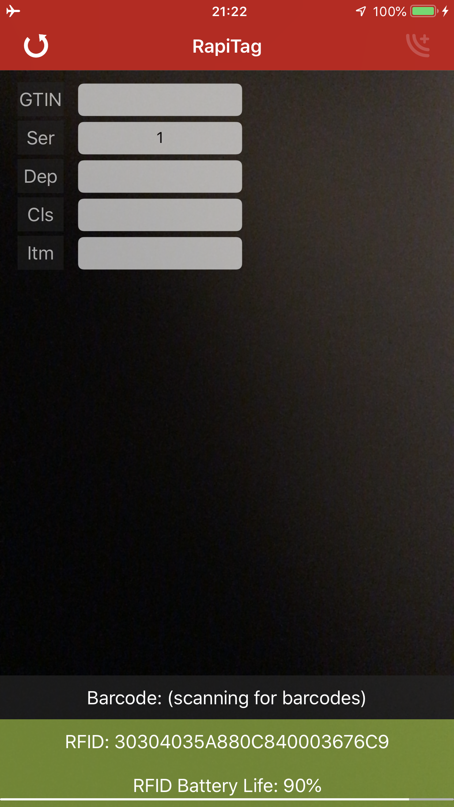If an RFID tag was already read, it will be displayed:

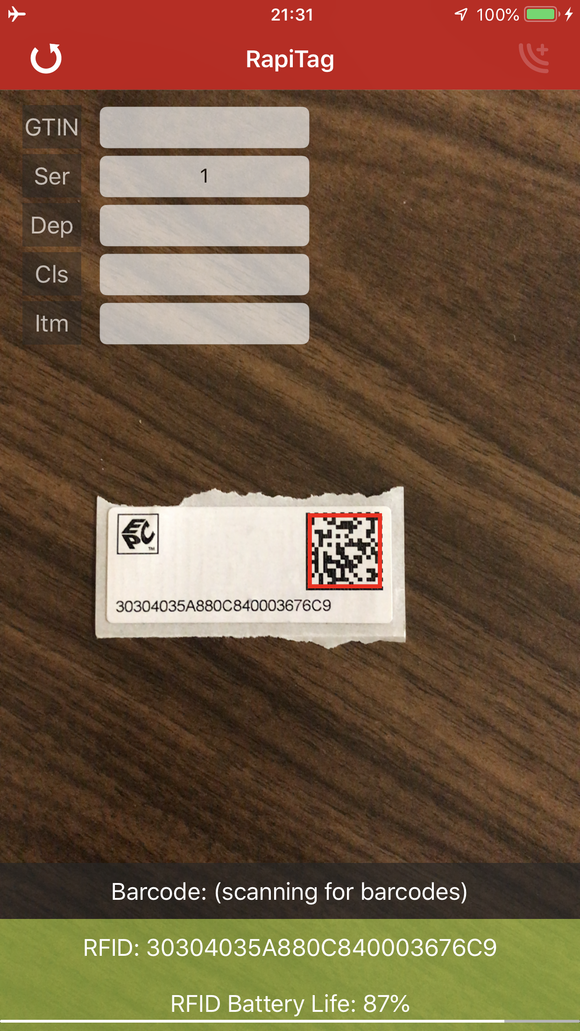Instead of reading the RFID tag you can also scan the printed barcode some stock tags:

If you want to enter product data from an existing UPC/EAN barcode, position the barcode for the camera to read it. Once read, you will see a green rectangle on the barcode image and the number will be displayed.

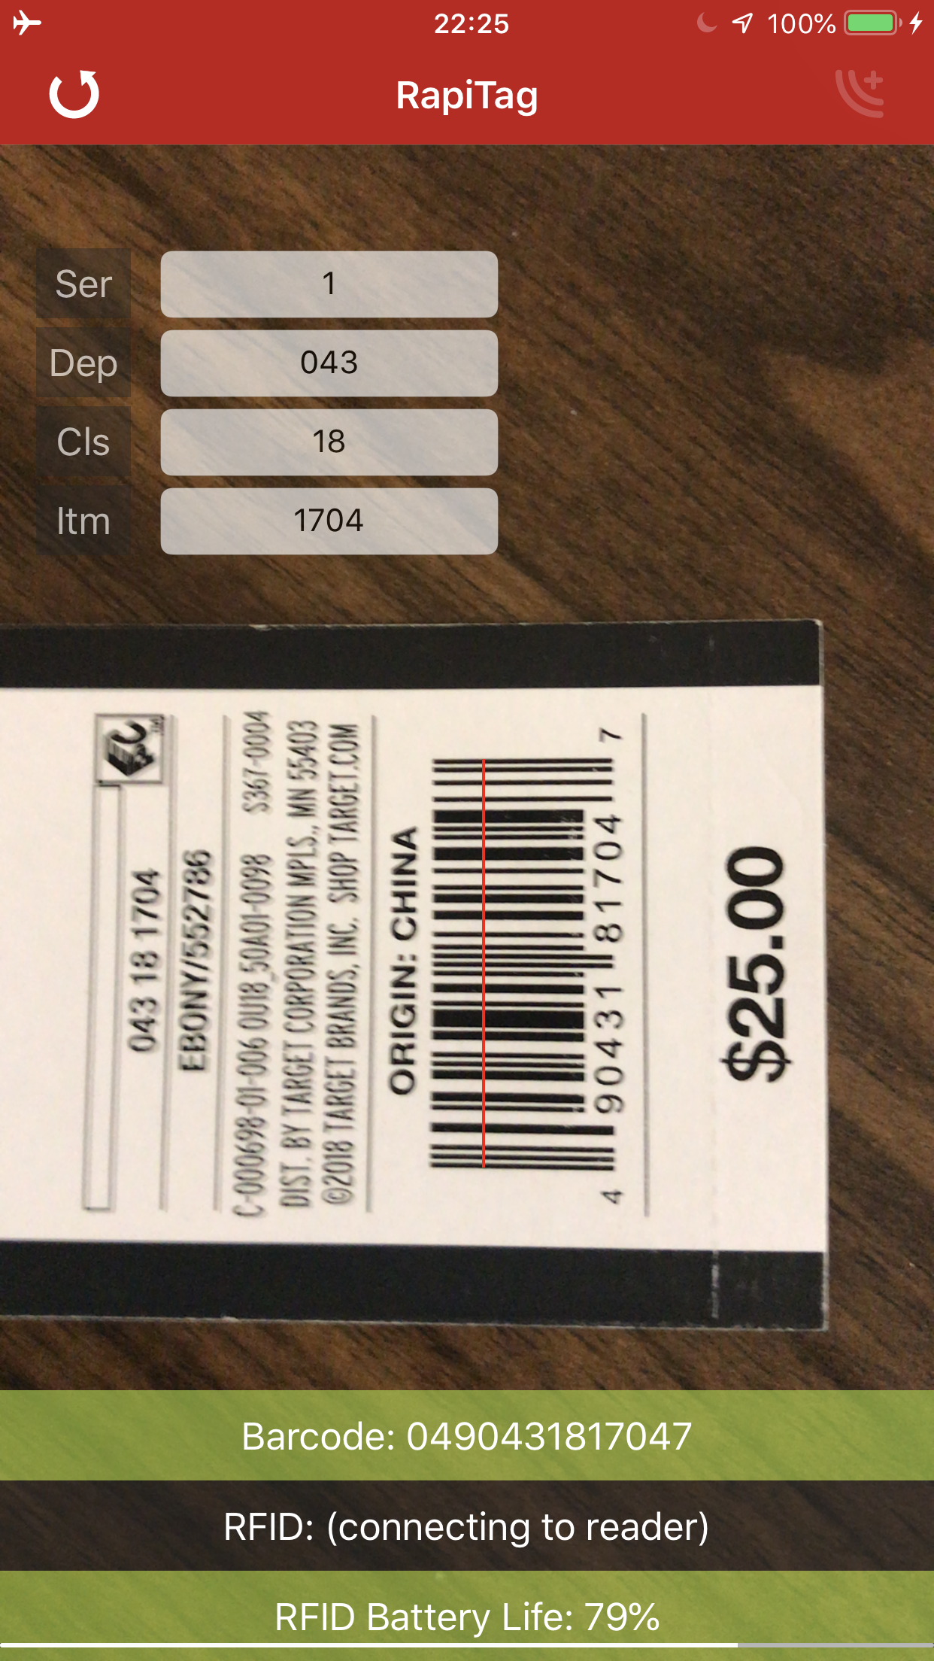All of the input fields will also be populated. If it is a DPCI, then the GTIN input will be hidden. If it is a GTIN, then the DPCI input fields will be hidden.

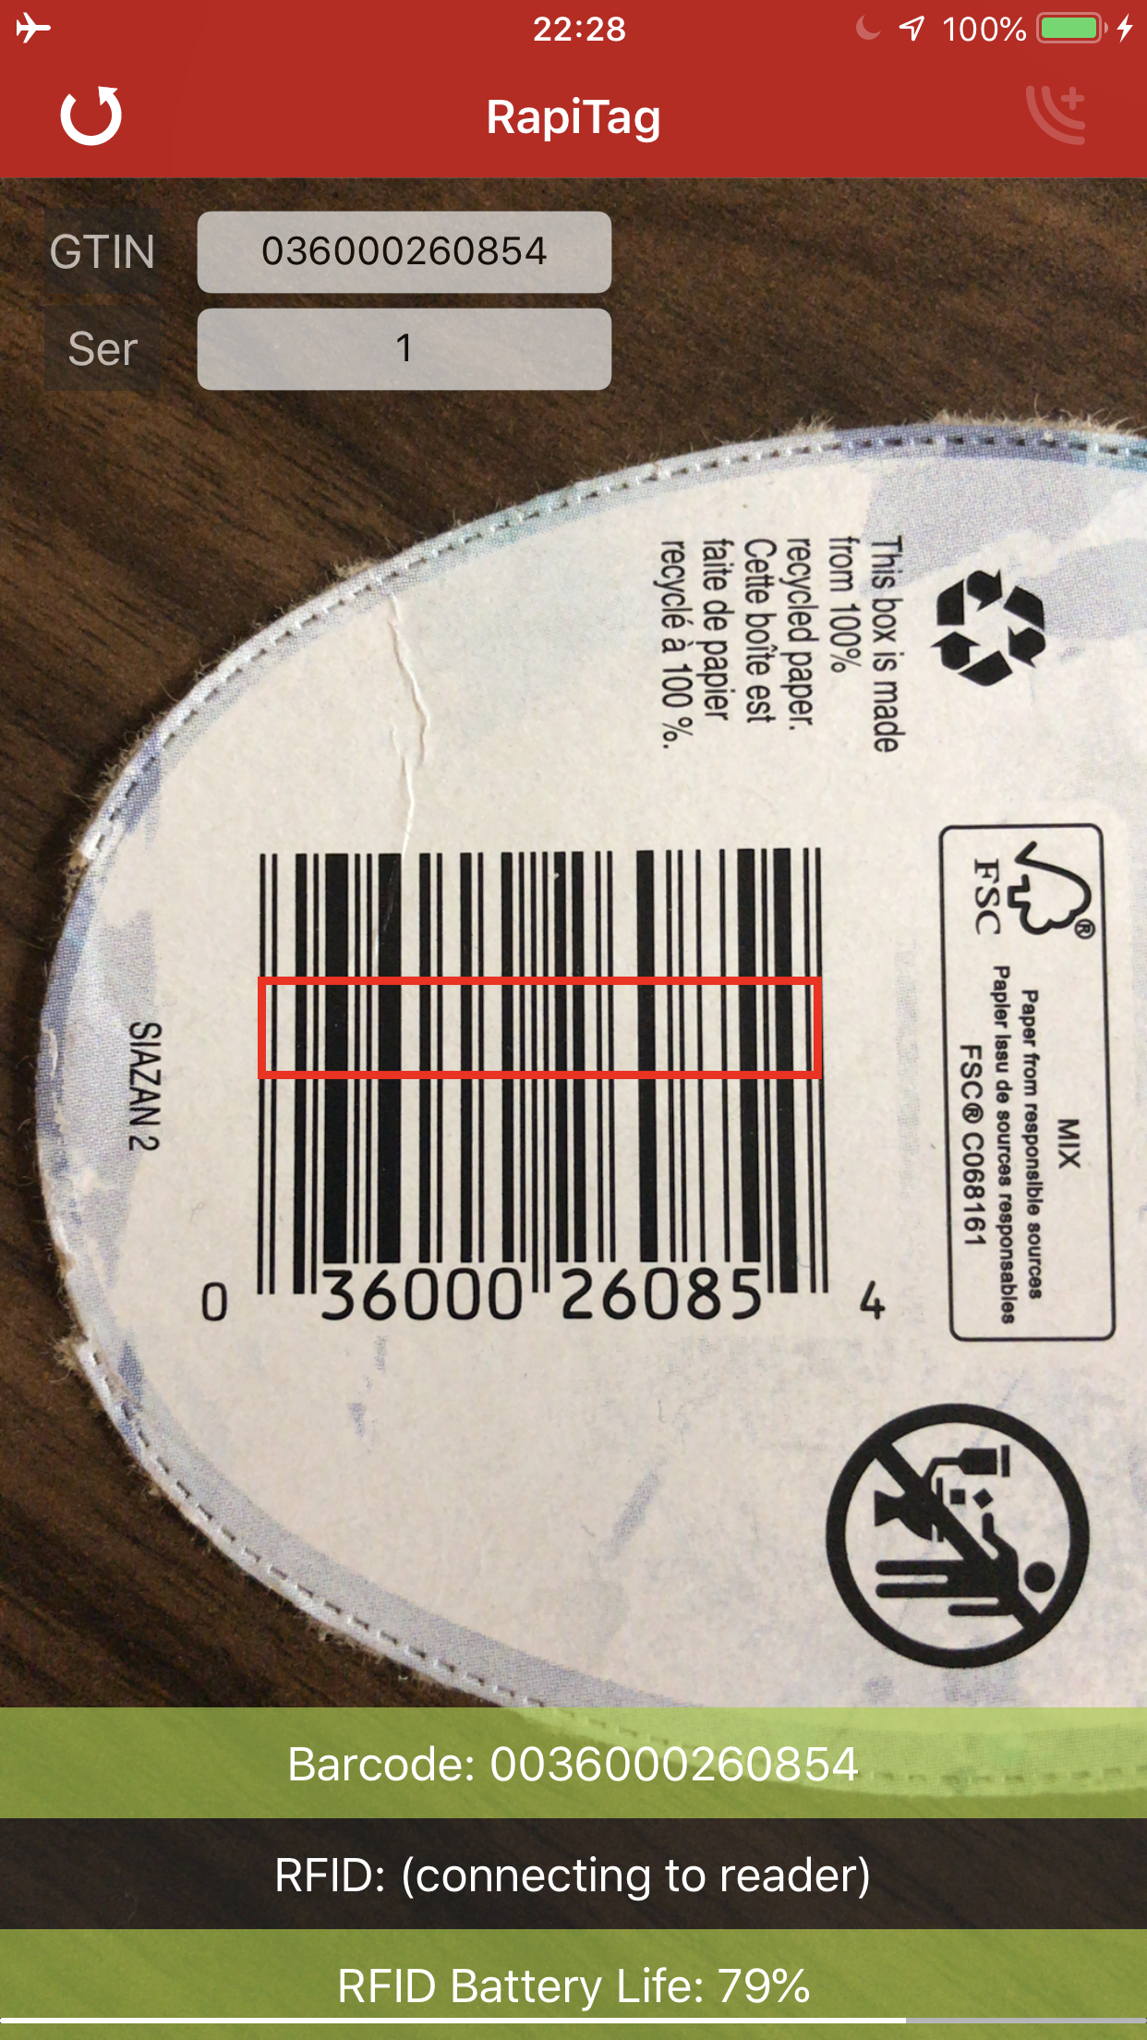

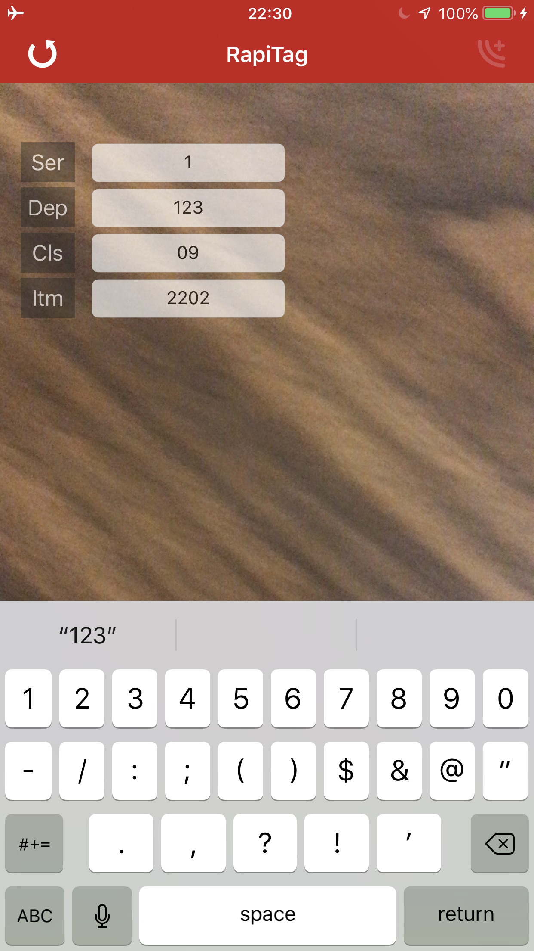

You can click on any field and manually enter data as well. You must hit “return” to accept any changes.

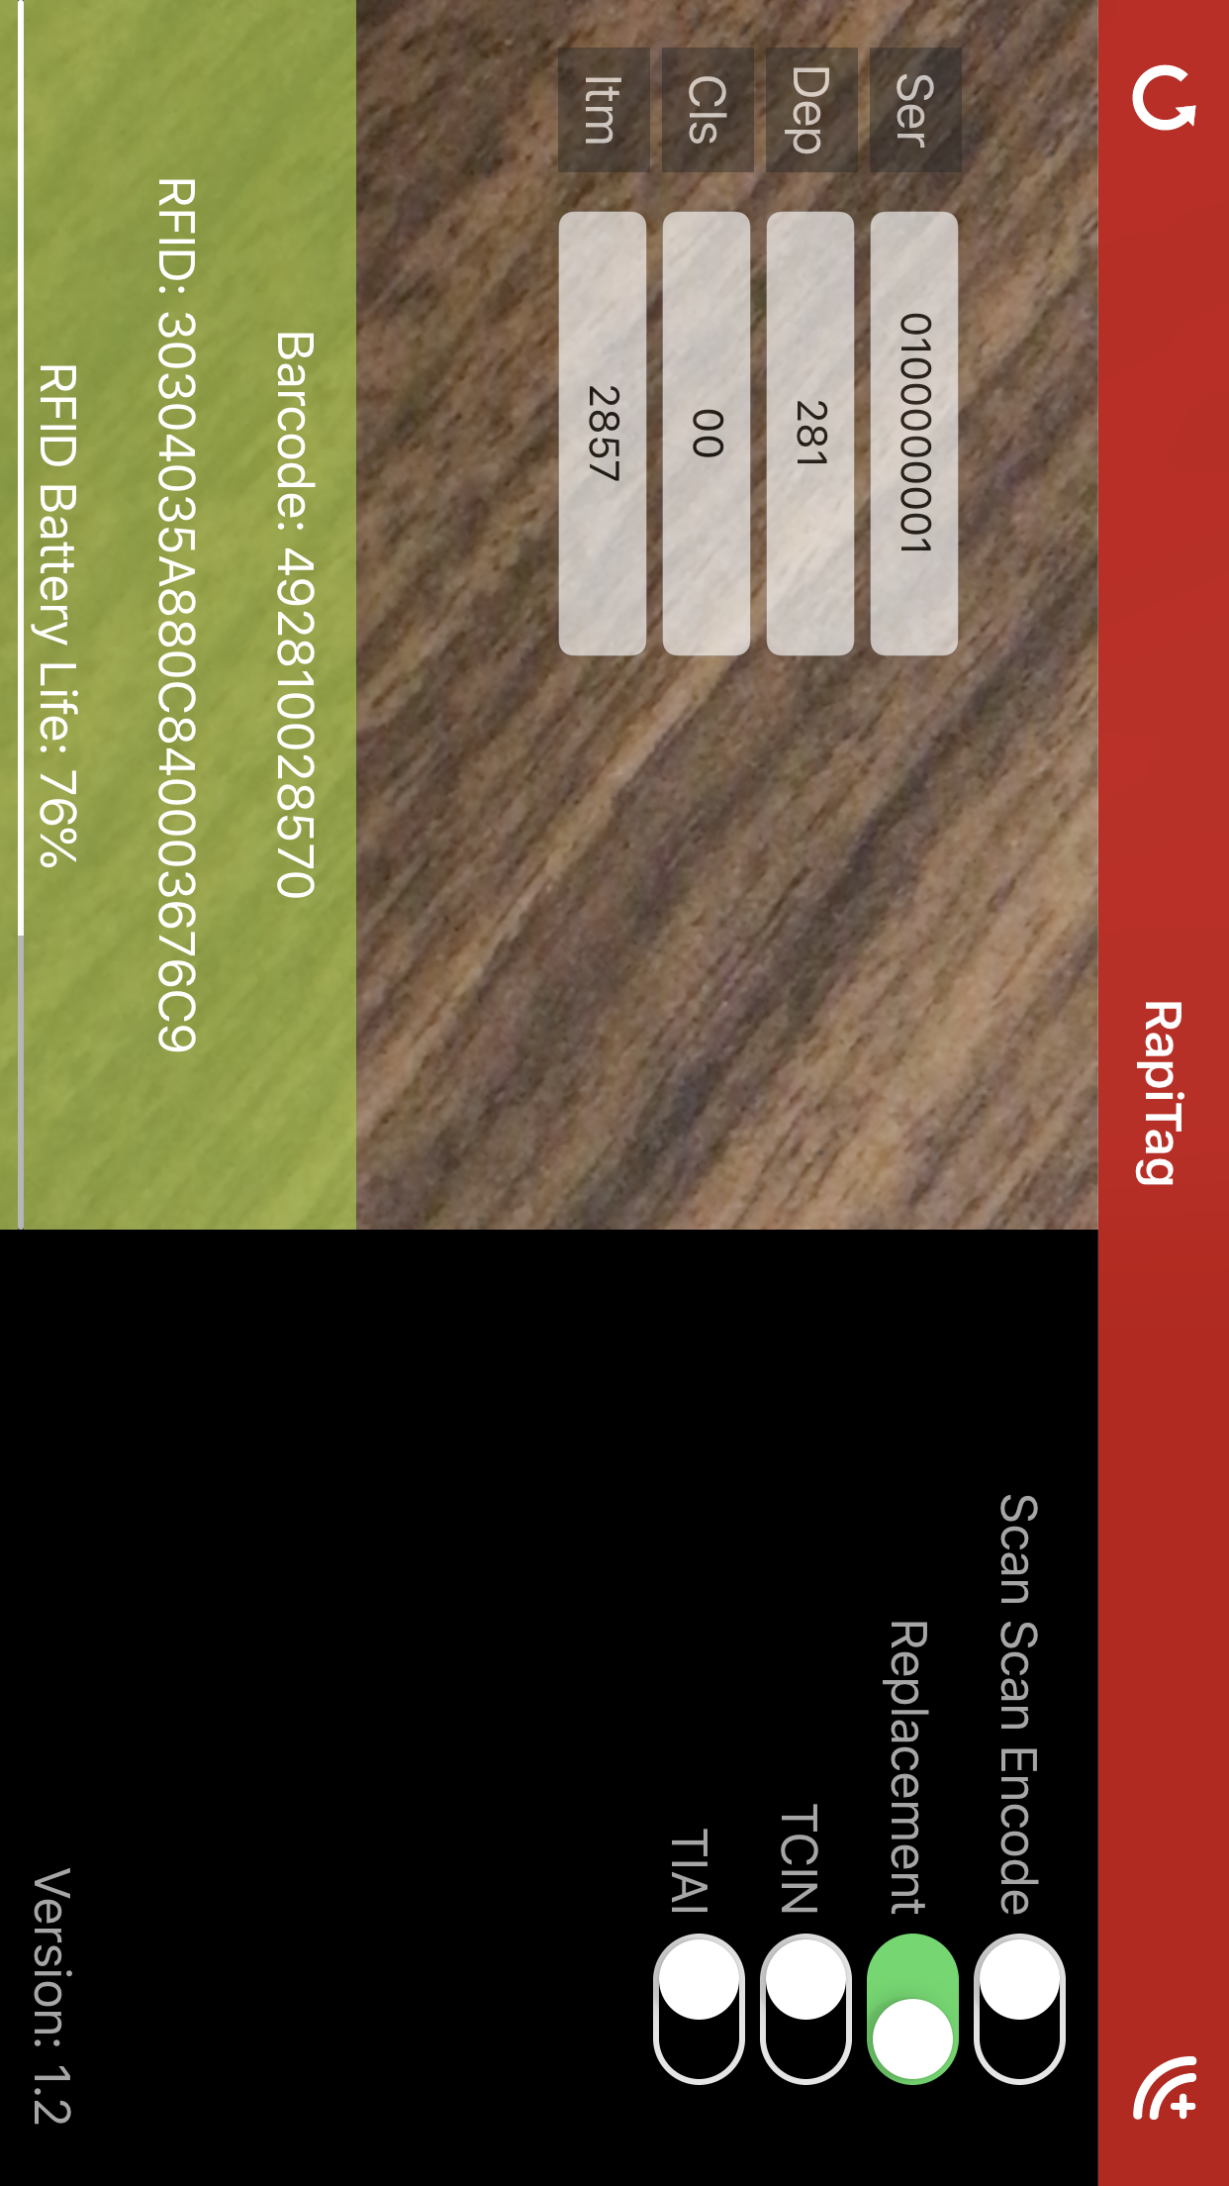If you are encoding a replacement tag, you **MUST** use GID encodings, even if the tag is a GTIN. To do this, turn the device sideways so you can see the “Replacement” switch and turn it on. This overrides the default and encodes national brand GTINs using the Target proprietary GID encoding scheme. The serial number for replacement tags **MUST** start with ’01’, ‘02’, ’03’, or ‘04’, indicating the provisioning authority:

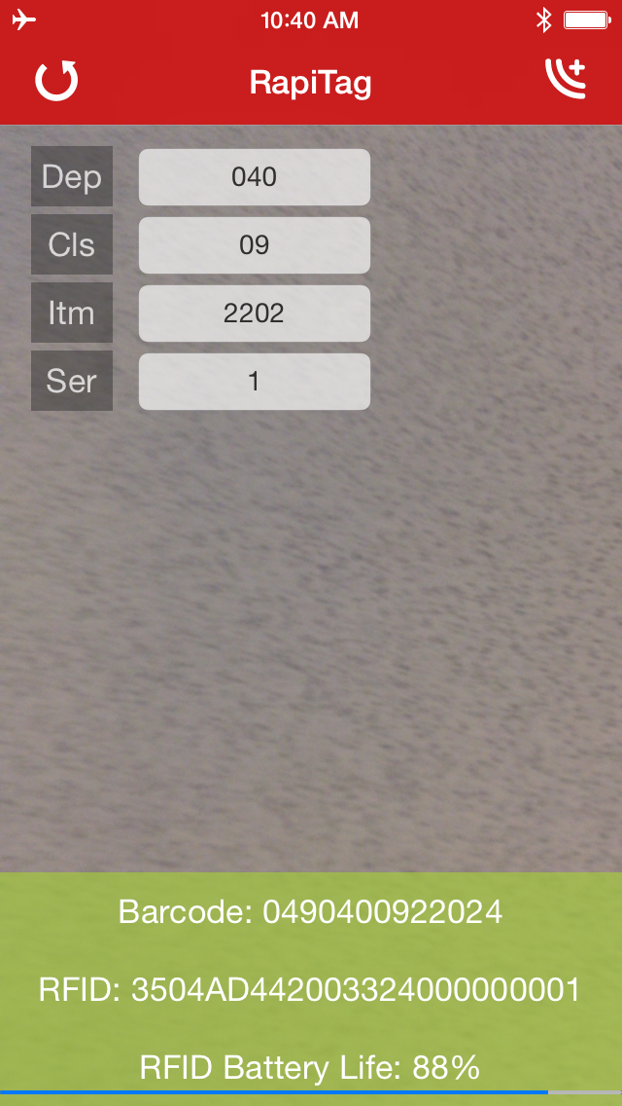Once both the EPC tag is read, and the proper input collected, the Encode button in the upper right is enabled:

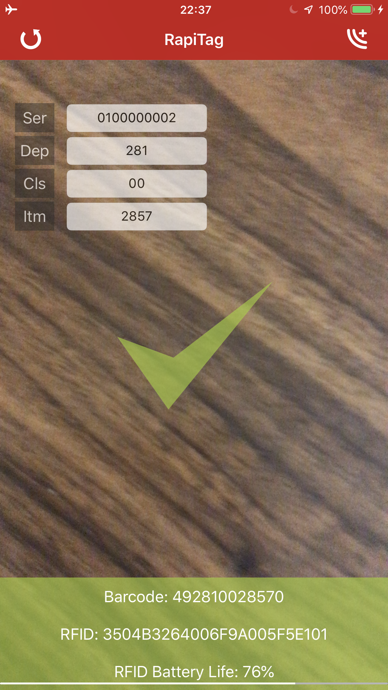Keeping the EPC tag in range, if you press the encode button, RapiTag will attempt to encode the tag. If successful, a green check mark is displayed and the Barcode and RFID fields will be green. The serial number will be automatically incremented by 1 to facilitate rapid encoding:

If it fails, then a red circle with a line through it will be displayed, and the Barcode and RFID fields will be red.

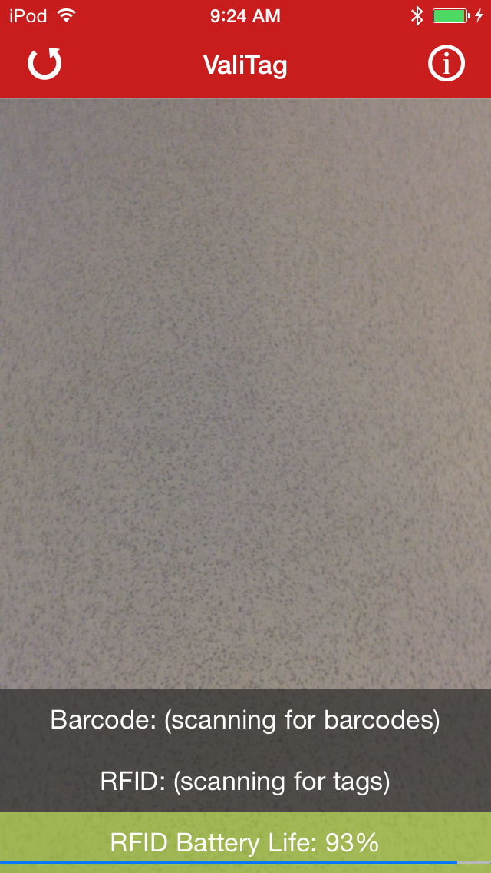

To read another tag, or start over, press the reset button on the upper left:

## New in this release

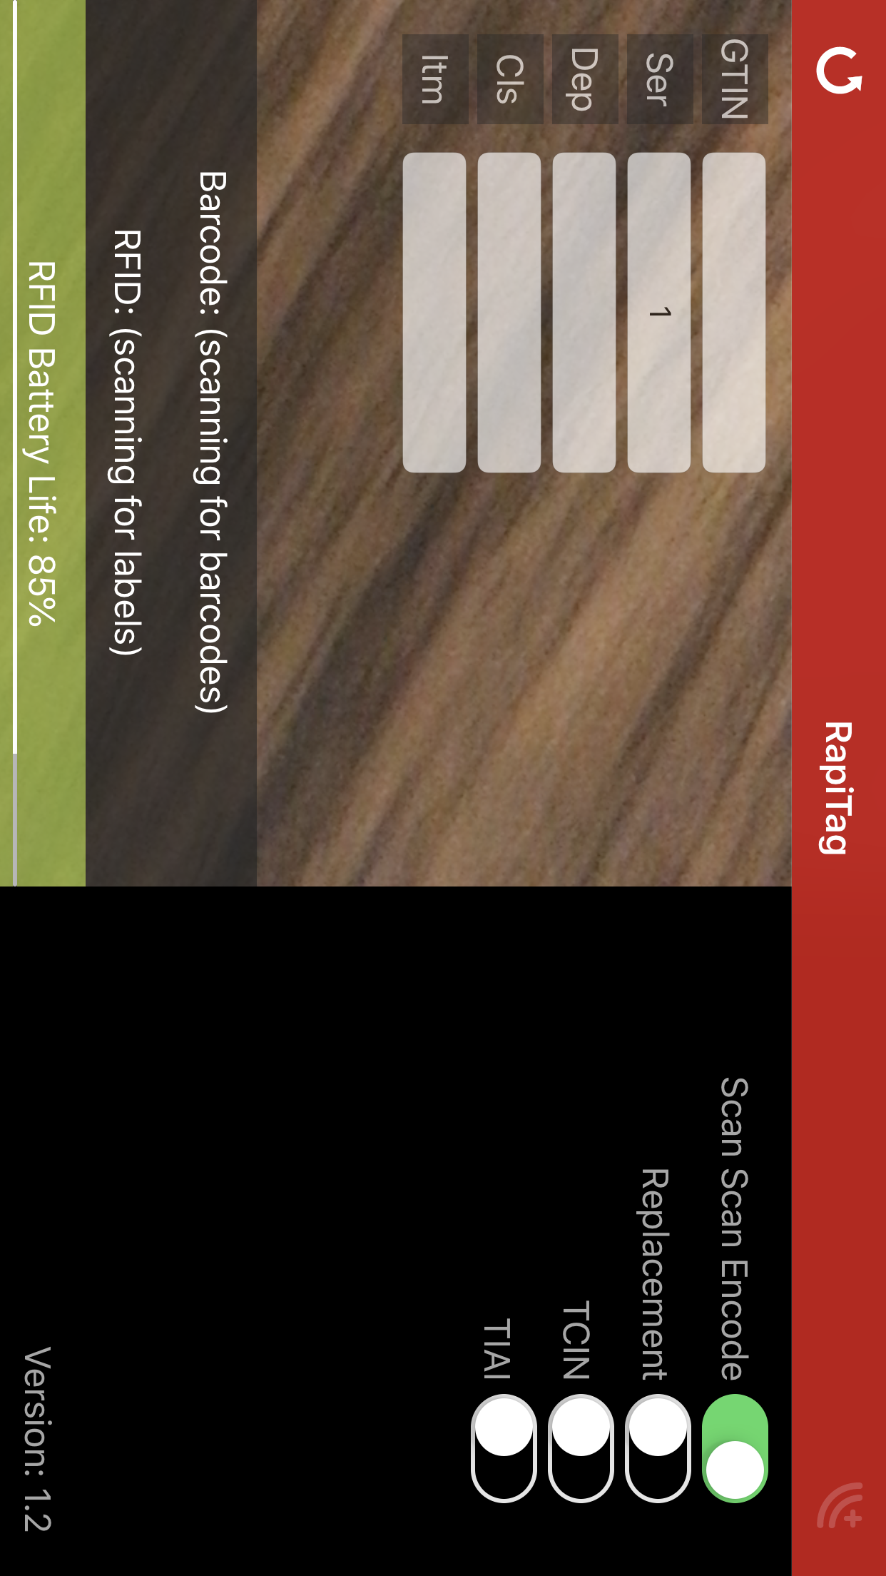If you want to automatically encode the barcode after both the RFID label and the product label have been scanned, turn the phone sideways and set the Scan Scan Encode mode:

In this mode, as soon as two barcodes are scanned, the tag is automatically encoded and the fields cleared. Success is indicated by a green check and failure by a by a red circle. This expedites the encodings of many tags.

## TCIN Encodings

Target’s modern, omnichannel supply chain leverages a common Target Corporation Item Number (TCIN) to identify all retail items. This is a random 10 digit number assigned by our new Product Information Management system (PIM) and is currently used by our online properties and modern supply chain systems. The TCIN identifies an item at a more granular level than the historical DPCI, and allows for correct identification of the exact product that the guest desires (e.g. Batman vs. Superman costume, which may be the same DPCI).

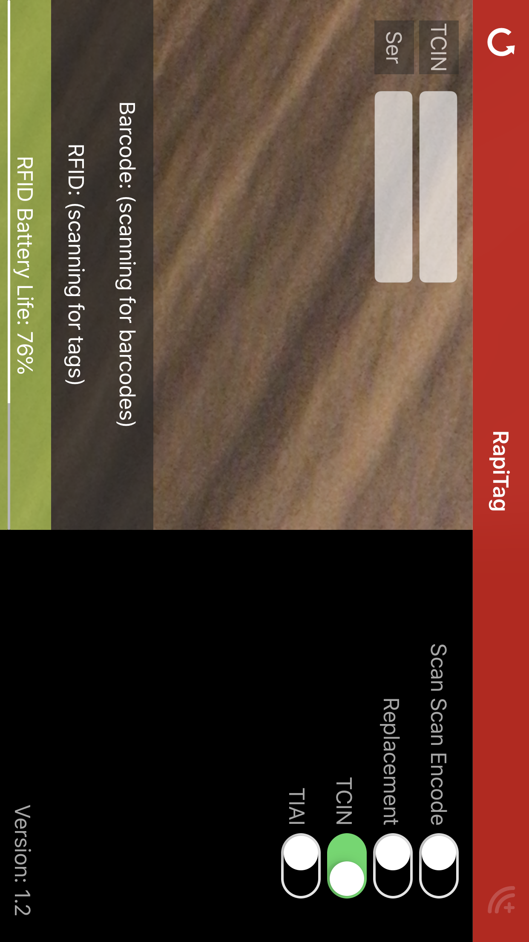A TCIN is random with no inherent logic so the number itself cannot identify the item without referring to the product catalog. The TCIN is also never represented in barcode format so must be mapped to associated UPC barcodes.

To access TCIN mode, turn the phone sideways and select the TCIN switch:

Note: It is the serial number that makes an TCIN encoded in an RFID tag unique. To ensure uniqueness, RapiTag uses a random number generator for the serial number, so you can and should leave it blank. This allows you to quickly generate many TCINs by simply bringing a new RFID tag into range and hitting encode.

You can use the Scan Scan Encode mode to quickly encode many TCINs.

## TIAI Encodings

Target tags and tracks many non retail items. These tag populations may be comingled, so it is imperative that the EPC encodings conform to a set standard for uniqueness so as to not interfere or overlap with the EPC encodings of retail items (e.g. a shelf tag next to a tagged retail product can both be read and not interfere with each other). There are many categories of non-retail items.

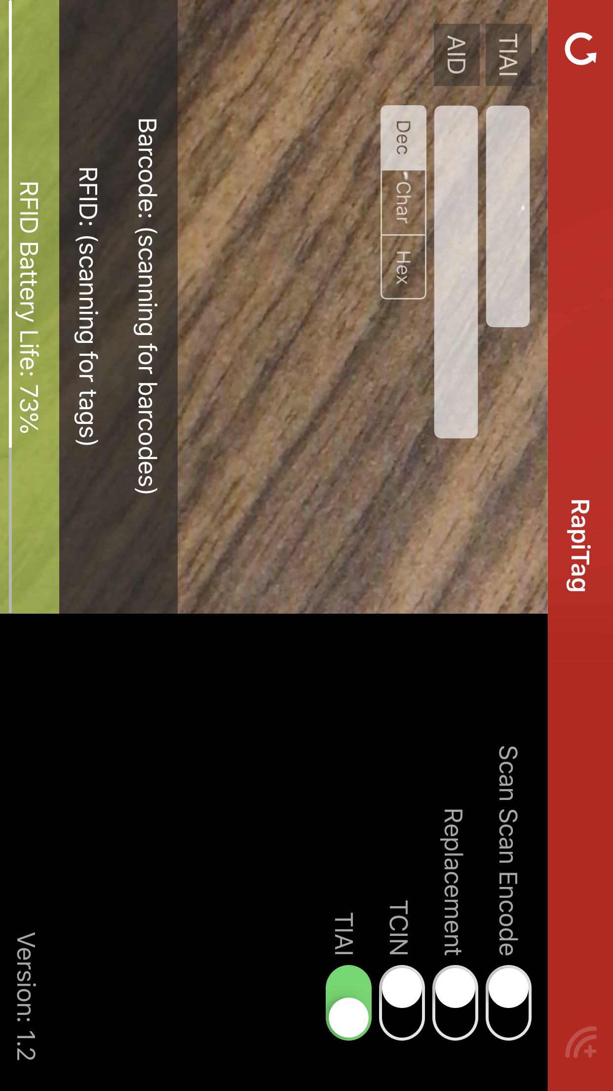The many and varied asset tracking systems in use at Target generate their own unique asset IDs (e.g. shelf IDs or Team Member handhelds). The TIAI solution leverages these unique Asset IDs wherever possible.

To access TIAI mode, turn the phone sideways and select the TCIN switch:

Note: it is the asset ID encoded in an RFID tag that makes it unique. The asset ID is issued by the asset reference, and a three digit designator for same is contained in the TIAI field. For a complete list of assigned asset reference systems, contact Target’s RFID team.

The system that issued the unique asset ID is responsible for how it is encoded and decoded, and guaranteeing uniqueness. There are three options to encode: Dec (up to a 21 digit decimal), Char (up to 12 alpha numberic characters) and Hex (18 digit hexadecimal). These can be set by the user, or automatically set after scanning an asset ID barcode.

You can use the Scan Scan Encode mode to quickly encode many TIAIs.

## Automatic Configuration

You can automatically set the configuration settings by creating and scanning special 2D Aztec barcodes. The encoded text should be one of:

MODE|DEFAULT|SCANSCAN|ON

MODE|DEFAULT|SCANSCAN|OFF

MODE|REPLACE|SCANSCAN|ON

MODE|REPLACE|SCANSCAN|OFF

MODE|TCIN|SCANSCAN|ON

MODE|TCIN|SCANSCAN|OFF

MODE|TIAI|ASSETREF|5|SCANSCAN|ON

MODE|TIAI|ASSETREF|5|SCANSCAN|OFF

MODE|TIAI|ASSETREF|5|TYPE|DEC

MODE|TIAI|ASSETREF|5|TYPE|CHAR

MODE|TIAI|ASSETREF|5|TYPE|HEX

MODE|TIAI|ASSETREF|5|TYPE|DEC|SCANSCAN|ON

MODE|TIAI|ASSETREF|5|TYPE|DEC|SCANSCAN|OFF

MODE|TIAI|ASSETREF|5|TYPE|CHAR|SCANSCAN|ON

MODE|TIAI|ASSETREF|5|TYPE|CHAR|SCANSCAN|OFF

MODE|TIAI|ASSETREF|5|TYPE|HEX|SCANSCAN|ON

MODE|TIAI|ASSETREF|5|TYPE|HEX|SCANSCAN|OFF

Here are the barcodes:

   

  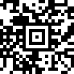 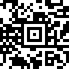

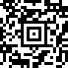 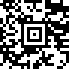 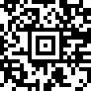

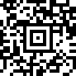 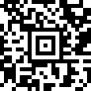 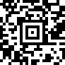

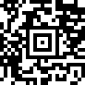 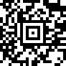 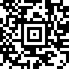

## Battery Life

Important note: the power settings on the RFID reader have been turned down enough so that only tags within the immediate range of the reader will be read and encoded. You should be able to keep tags at arm’s reach away on either side and they won’t be affected, but occasionally they are. You may need to test this in your environment until you are sure you are reading and encoding only the RFID tag that is in range. To keep the application simple, these settings are not configurable.

When the battery of the reader gets too low, charge it (or in the case of the Zebra reader, replace the battery).

## Basic Troubleshooting

* **No Battery life displayed**
  + This can be an indication that the reader is not properly connected, but not all readers report their battery life in the same manner, so it is not a guarantee.
  + Check the reader connections (headphone plug or Bluetooth)
* **Connecting to reader message**
  + If this message is displayed, press the reset button in the upper left and try again.
  + This is more often an issue with a Bluetooth reader.
  + If after a couple of resets it still won’t connect
    - If you are using an attached reader, check the plug connection and restart
    - If you are using a Bluetooth reader, proceed to the next step
* **Bluetooth connection fails**
  + Exit RapiTag
  + Go into iOS Settings, Bluetooth and click on the ‘i’ button to the right of the RFID reader
  + Select “Forget this Device” and accept

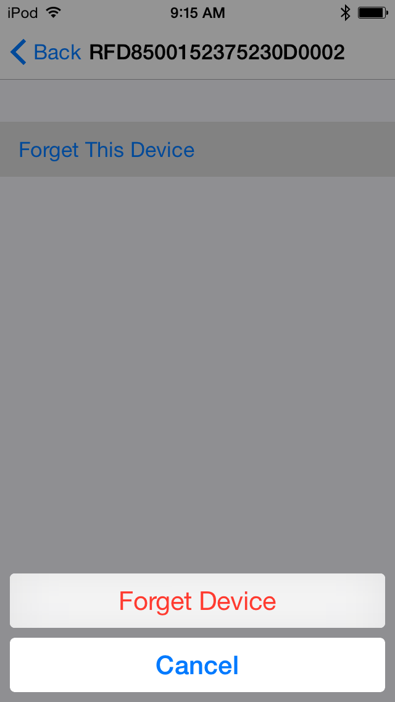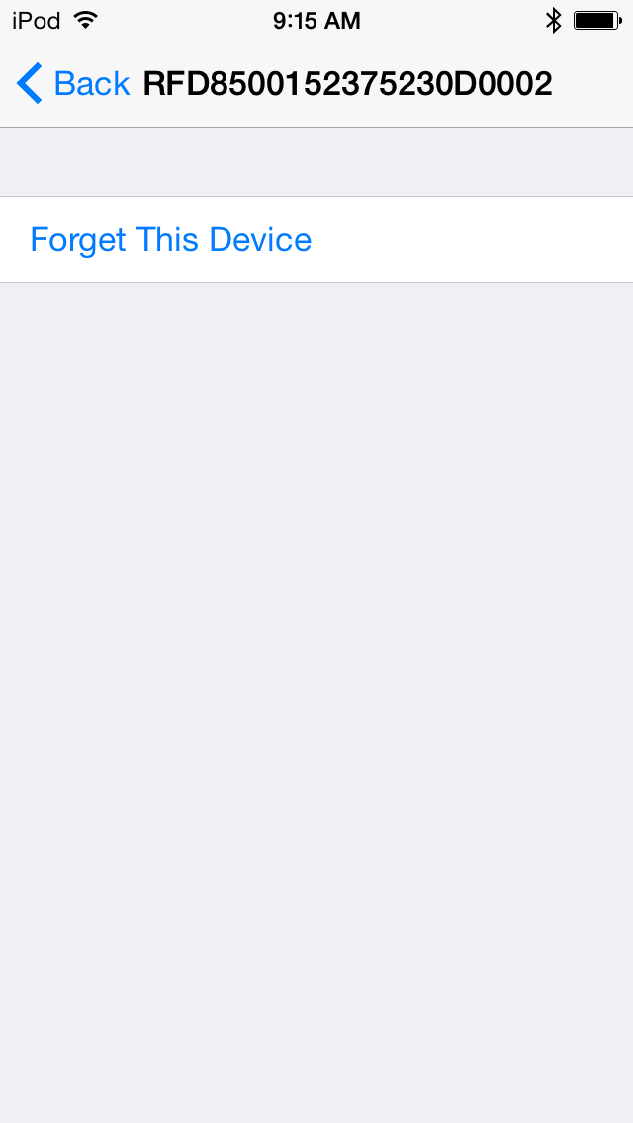

* + Once forgotten, go through the setup steps outlined in “Bluetooth Setup” to reconnect the reader.
  + Wait until it is connected and then relaunch RapiTag.
  + The reader should connect automatically.